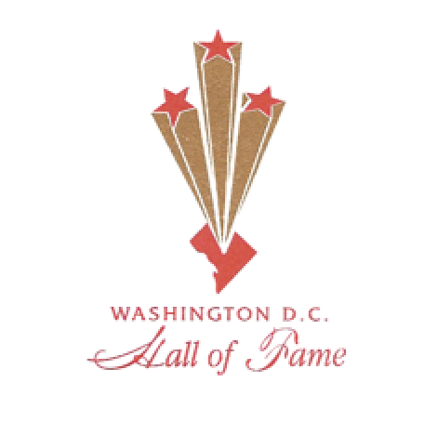 | WASHINGTON DC  HALL OF FAME SOCIETY, INC.  Official Nomination Forms  Nominee and Nominator Page  (Please read Page 2 first)
Please complete all blanks on this Nomination Page. Indicate N/A (not applicable) if it does not apply to Nominee. If more space is needed, please attach additional pages or enclose resume’ with the application. All responses must be Typed or Printed Clearly and returned by
Monday, MAY 31, 2021, to wdchalloffame@gmail.com

Nominee Information:

Name: _________________________________________ Title (Mr., Mrs., Ms., Dr., etc.): ________Ward: ________

Street Address: ______________________________________________________________________________

City/State: _______________________________________________________ Zip Code: ____________________

Telephone
Home: ______________________ Fax: _________________________ Cell: _____________________________

Email: ______________________________________________________________________________________

Nominator Information:

Name: ___________________________________ Title (Mr., Mrs., Ms., Dr., etc.): ______ Ward: ______

Address: ________________________________________________________________________

City/State: __________________________________________ Zip Code: _______________

Telephone:
Home: ____________________ Fax: ___________________ Cell: _________________________

Email: _________________________________________________________________________________________

How long have you known the Nominee? ____________________

The official application must be completed and
e-mailed no later than 5:00 PM, Monday, May 31, 2021, to:
wdchalloffame@gmail.com
***In this time of COVID, we are only accepting Nominations through e-mail***
Washington DC Hall of Fame Society, Inc.

PROGRAM INFORMATION & GUIDELINES

Recognition by the District of Columbia Hall of Fame is an esteemed tribute to Washington, D.C. residents who have proudly distinguished themselves in the City in many areas of service.

These Honors are open to all Washington, D.C. residents who are at least 50 years old at the time of nomination. The nominee must be a current resident of the City and have resided continuously in the Nation’s Capital for at least ten years.

Candidates cannot be self-nominated. The Nominator must provide information about the Nominee and him/herself as requested in the Nominee/Nominator Page (page 1). All information must be printed or typed. Additional pages and/or portfolio/CV will be accepted. Applications will remain active on file for a period of two years. Each Nominee should have demonstrated contributions that have resulted in the improvement of the quality of life for Washington, D.C. residents. The Nominee must show evidence of strong and effective community involvement in the growth and development of the District of Columbia.

A distinguished panel of judges for each category will select Hall of Fame Honorees based on the six criteria outlined below. The Washington DC Hall of Fame Society’s Executive Committee will finalize the selection process.

Criteria for Selection:

- Residency: Nominee must be a current resident of the City and must have resided continuously in the Nation’s Capital for at least ten years. Please list all places of residency, including addresses, dates and Wards where domiciled.

- Pioneering Work/Experience: The contributions and work accomplishments that brought the Nominee local, national or international recognition must be indicated.

- Organizational Leadership: Nominator must list the names and dates of all organizations or companies in which the Nominee held or holds leadership position(s), including as a founding member or a creator of innovative program(s).

- Professional Achievements: Nominator must indicate the Nominee’s professional accomplishments at the local, regional and national levels. Please list elected or appointed positions, outstanding awards or citations, and special work performed in the City. Notable creative and artistic work should also be listed.

- Scholarship: Nominator should indicate all publications and writings, educational awards, inventions, and exceptional performances including poster sessions and exhibits.

- Community Leadership: Nominees must be actively involved in the community (City). List all positions held in community groups or organizations, including leadership.

Please designate the category most appropriate for your nominee ( X only one category):
 | Business |  | Education |  | Religion
 | Communications |  | Health |  | Sports
 | Cultural Arts |  | Law |  | Science/Technology/  Architecture
 | Civic/Community Development |  | Politics/Government |  | Science/Technology/  Architecture

***In this time of COVID, we are only accepting Nominations through e-mail***

Washington DC Hall of Fame Society | NOMINEE BACKGROUND INFORMATION
Application due: May 31, 2021  All Applications Remain Active for Two Years | Date Submitted: _________________________________

Eligibility Requirements: The Nominee must be a current DC resident who has resided continuously in the City for at least ten (10) years. The individual must be at least 50 years of age at the time of nomination.

Residential Address: ______________________________________________ Zip Code: ________________
Number of years at this residence: _________ Ward ___________
Additional residence: _______________________________________________ Zip Code: ________________

(Please attach additional sheets and/or Portfolio/CV if needed)
Education:
Institution: | Degree: | Year conferred:

Pioneering Work/Experiences (Include Scholarship, Publications, Projects, Inventions, Local/National Awards, Speeches, etc.):

Community Leadership and Involvement (Include titles and positions, where appropriate):

Organizational Membership/Activities (Include titles and positions, where appropriate):

Noteworthy Contributions/Achievements/Honors/Awards (Professional, Civic, Educational, etc.):

